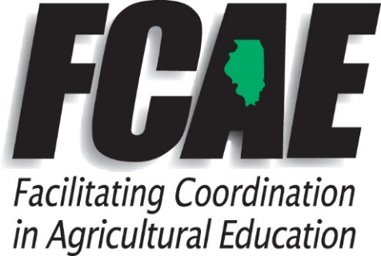
Lucas Allen
Agriculture Education Program Advisor
2015 Manchester Rd
Wheaton, IL 60187
(C) 815-530-2065
lallen@ILAgEd.org

2020 Fall Ag Teacher Section Meeting
District 2 FCAE Report

Staffing updates - John Heiser, Riley Duckworth
Distribute free pork and beef cuts meat posters and AITC calendars

- www.ILAgEd.org Website
  - Update Profile Info
    - School Information including administrators, etc.
    - Personal data, upload a photo
    - Courses- enter at the bottom of your profile page. Use 8/1/20 as course start, 6/30/21 end.
    - January- Add all 2nd-semester students to ILAgEd website or have students enter.
  - Course roster information entered BY STUDENTS each selecting a course by Oct. 1
    - Use IL AgEd website- NOT AET or FFA.
    - “How-to” videos are found in Teach → Educator Resources
  - Remote Learning Resources

- FY21 Agricultural Education Line Item funding level - level funding at $5 million

- Key legislative contacts list (Senate & House Appropriations)
  - Please make sure to send thank you notes for supporting agricultural education to your local Representative and Senator.
  - Invite legislators to chapter events.
    - Local legislator finder -
https://www.elections.il.gov/ElectionOperations/DistrictLocator/AddressFinder.aspx

- Incentive Funding Grant
  - IWAS at ISBE.net - Set up accounts or request access from superintendent (if at a new school)
  - FY20 - Spend allocations
  - FY21 – IWAS budget will be loaded in August
  - Incentive Funding Grant available to start/operate middle school Ag programs.

- Three Circle FFA & SAE Grant
  - FY20
  - Record both START and END times (AET preferred). Type end time in the description field.
  - July 1, 2020 to June 30, 2021 - Grant time period for 400 hours.

- Elite Conference - September 17 - Virtual
  - Resources to encourage students to consider teaching Ag as career
  - Grade 9-12 and students could repeat

DUE OCTOBER 1 in IL AgEd website (www.ILAgEd.org)
- Course rosters entered (students select courses)
- FFA Membership submitted to State online
- FFA Dues submitted to State office
- FFA Strategic Plan submitted electronically

- IAVAT Dues paid by October 31st

- Improving Ag Ed Programs Grant - Not offering this year

- ITCS Resources - order form

- Agricultural Education Enrollment(a) and FFA Membership(b) Increase to Historical Highs
  - 2016-17 - 31,655
2017-18 - 33,050
2018-19 - 34,285
2019-20 - 35,651 unduplicated students representing a 4% increase(1366)

  - 2016-17 - 17,535
2017-18 - 18,453
2018-19 - 19,099
2019-20 - 20,671 representing an 8% increase(1572)

10. On-Site and Virtual Assistance available

11. District Professional Development ideas

12. ISBE New Pathways and Course Matrix

13. Chapter visit exchange - Not available at the moment

